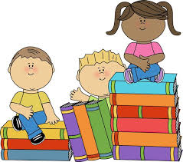
Hot Readers
First Grade Book Report
2016-2017

Student: __________________________________ Teacher: _____________________________
Title of Book ___________________________________________________________________
Author _______________________________________________________________________
Illustrator _____________________________________________________________________
Date Read ___________________________ Parent Signature _____________________________

This book was about… _______________________________________________________________________
_______________________________________________________________________
_______________________________________________________________________
_______________________________________________________________________

I liked this book because… _______________________________________________________________________
_______________________________________________________________________
OR -
I did not like this book because…
_______________________________________________________________________
_______________________________________________________________________

My favorite part of the book was… _______________________________________________________________________
_______________________________________________________________________
_______________________________________________________________________

