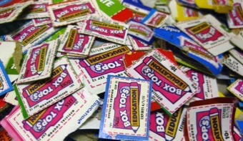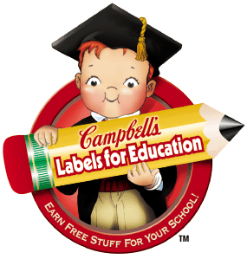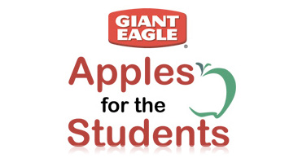
Dear Parents,
Here at Northwestern Primary School, the Trash to Treasure Committee of the PTO collects your “trash” and turns it into “rewards” to benefit our children. You can help by sending in UPC’s, Labels, and Box Tops from various products as well as other reward programs.
Giant Eagle sponsors Apples for the Students as well as e-Labels for Education. Apples for the Students is a points earning system for our school simply by creating an account at gianteagle.com and registering your Advantage Card. Every time you use your card, you earn points for our school!! You can register your card by either visiting http://www.gianteagle.com/Save/Supporting-Our-Schools/Apples-for-the-Students/ or by calling 1-800-553-2324 and use our school ID #0784.
Campbell’s offers www.elabelsforeducation.com where you may link your Giant Eagle Advantage card to Labels for Education and every time you purchase items with applicable labels, our school receives an extra point in addition to the points we submit from the labels.
Box Tops for Education offers 10 cents for every box top submitted and they issue checks to our school twice a year. Last year, the box top submissions paid for a portion of the new Fairy Tale book section in our Library. Check all your packages for “Box Tops” and get them to the school-the collection box is located right outside the school office door.
Labels for Education is another great rewards program for Northwestern. There are many labels AND caps you can collect that worth points in increments of 1, 5, and 10. Please visit http://www.labelsforeducation.com/ to view all the various brands that participate – over 2,500! There are also UPC’s you can find on other items such as Pepperidge Farm Goldfish boxes so cut those out as well! All the labels for education are submitted and earned as points that are redeemable as items our Teachers can use in their classrooms.
Target offers Take Charge of Education (TCOE) and all you need to do if you shop and use any (credit or debit) REDcard is register your card by visiting www.target.com/tcoe or by phoning 1-800-316-6142. Our school ID is 88967. Once you sign up for Take Charge of Education, your trip becomes a fundraiser for our school! You get 5% back on your purchases and Northwestern will receive 1% for all eligible REDcard purchases.
Tyson sponsors Project A+ and their website is www.projectaplus.tyson.com. We must submit a minimum of 100 labels at a time, however, each label is worth 24 cents for our school! A brand new program that runs through 3/31/15 gives schools 10 FREE Scholastic books for every 100 labels, IN ADDITION to the 24 cents earned for each label submitted!
Thank you very much for all your hard work in helping the Trash to Treasure Committee!!

