Blackhawk High School Spirit Sale

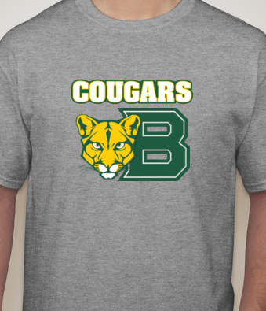
Styles: T-Shirt, Long Sleeve Tee, and Hoodie
Colors: Black and Light Grey
T-Shirt | Long Sleeve Tee | Hoodie
$13 | $15 | $25
Price:
ORDER FORM
Name: _________________________________________________
HR: _____________
ITEM A (cougars top--specify style and color)
T-Shirt qnt:______ | Long Sleeve qnt: _____ | Hoodie qnt: ____
Size(s): _________ | Size(s): ____________ | Size(s): ________
Color: __________ | Color: _____________ | Color: _________
Total: $ | Total: $ | Total: $

ITEM B (sweatpants)
Quantity: ________
Size(s): ___________
Total: $

ITEM C (senior infini17y t-shirt)
Quantity: ________
Size(s): ___________
Total: $

ITEM D (senior legen17ary top--specify style)
T-Shirt qnt:______ | Long Sleeve qnt: _____ | Hoodie qnt: ____
Size(s): _________ | Size(s): ____________ | Size(s): ________
Total: $ | Total: $ | Total: $

Orders & Payment are due by Friday, December 2 Senior Class Officers will collect orders & payment during homeroom
Item: A

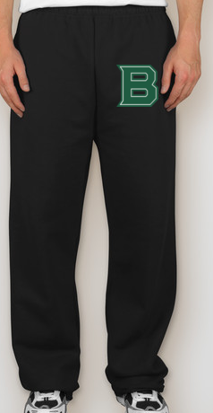
Style: Open Bottom
Color: Black
Price: $20
Item: B

Class of 2017 items:
Style: T-Shirt
Color: as pictured
Price: $13
Item: C

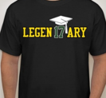
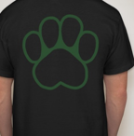

Item: D

Styles: T-Shirt, Long Sleeve Tee,
Grand Total: $_________
(Checks payable to BHS Class of 2017)

& Hoodie
Color: Black
T-Shirt | Long Sleeve Tee | Hoodie
$13 | $15 | $25
Price:

