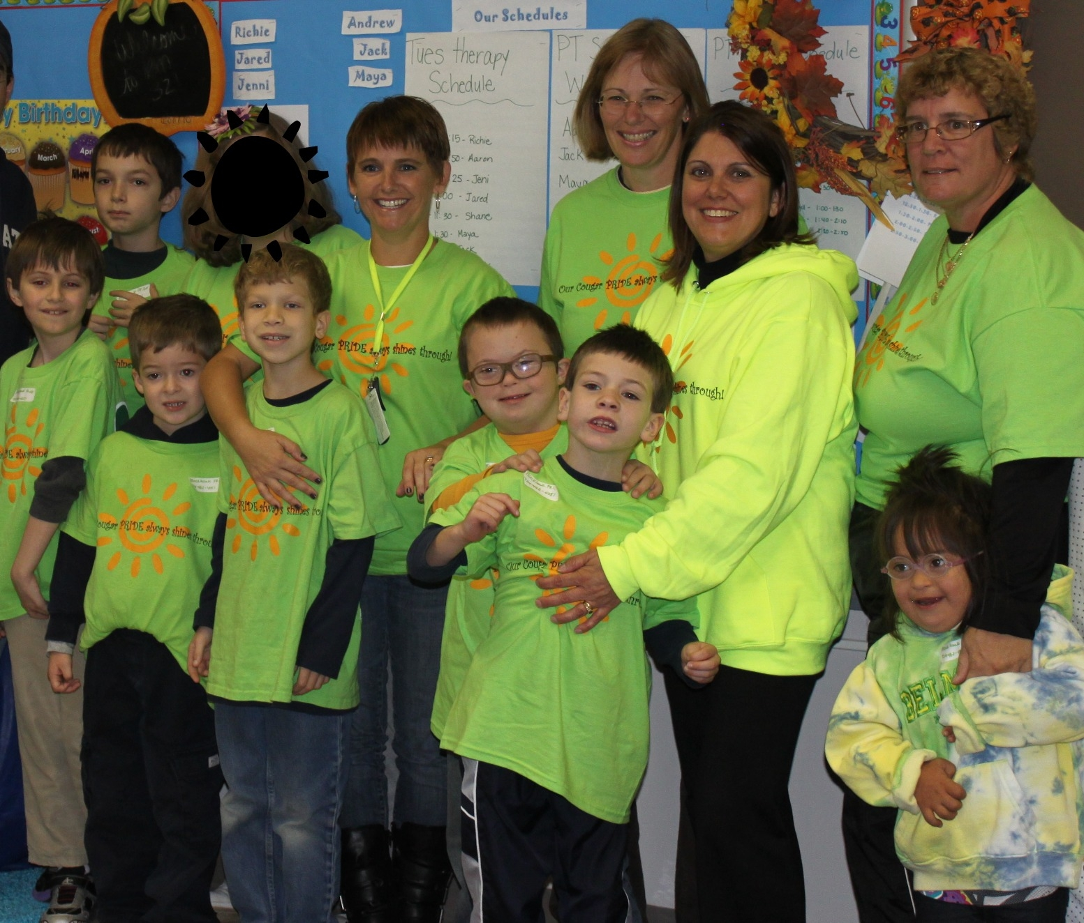

What is Cougar PRIDE?

An innovative program that embraces, supports, and challenges our students with exceptional needs. PRIDE has the following core components:

- Parent teaming
- Responsiveness to students
- Individual goals and instruction
- Developmentally appropriate instruction
- Educational foundations and standards

Your children, our students, will receive:
- Curriculum experiences with typical peers
- Necessary supports and services such as:
  - Speech/language
  - Occupational therapy
  - Physical therapy
  - Multi-sensory therapy
- Individualized goals and instruction
- Community based instruction
- Social skill development

